Curriculum Framework

Our School Vision

Inspiring Curious Minds

Whakahihiri i ngā hinengaro pakiki

Contents

The Big Picture

- Graduate Leave Profile

- Values Progressions:
Respect / Whakaute
Integrity / Pono
Community / Hapori
Courage / Māia

- Learning Design Model: GET IT - SORT IT - USE IT

Implementation of the Curriculum

- Responsive Curriculum Overview

- New Zealand Curriculum Learning Areas

- An Overview of the Planning Process

Key Supporting Documents

- Inclusive Procedures

- Literacy Progressions (Reading and Writing)

- Mathematics and Statistics Progressions

- Maori Progressions

- Student Agency

- Fox Glacier School Implementation of the New Zealand Curriculum

Graduate Leaver Profile

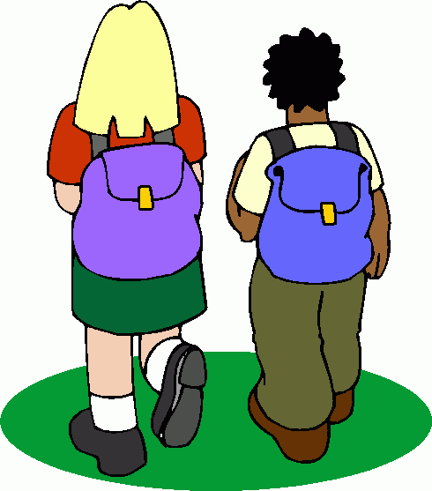

We want our graduates to be

caring, confident, successful learners who respect themselves, others, and the environment.

They will display curiosity in the world around them, and live by our shared values of

Respect / Whakaute
Integrity / Pono
Community / Hapori
Courage / Māia

Our learning design model guides teaching and learning through cycles of

GET IT - SORT IT - USE IT.

Our School Vision Progressions

Curiosity / Whakamatemate
I am curious about the world around me
and want to learn new things.
- I want to learn new things  - I am willing to take risks  - I have a strong desire to find out about myself and the world around me  - I ask questions and investigate the answers | Beginning | Developing | Applying
 | I can talk about what I would like to learn. | I am willing to take risks in my learning to learn new things, and with support I can plan the steps I need to take to find things out. | I can independently identify a new area of learning for myself, plan my inquiry, locate my resources, and carry it out.
 | I work with others to investigate the answers. | I am able to ask good questions and investigate the answers with a little support most of the time. | I am able to take my learning further by reflecting on my new knowledge and applying  it to other situations.

Our School Values Progressions

Respect / Whakaute
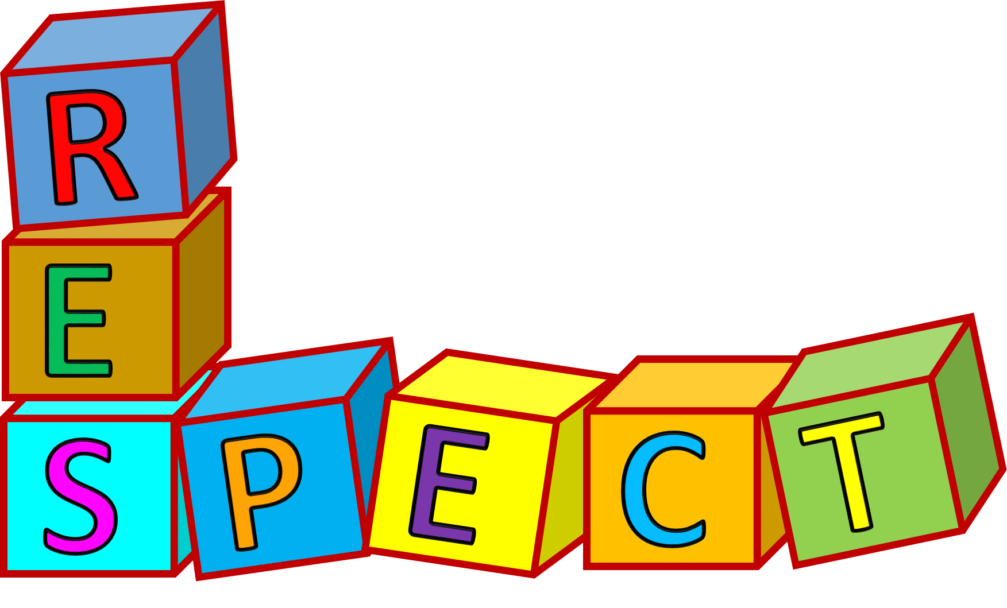 | I show respect for myself, others, and  the environment.
- I respect myself and others  - I treat others as I would like to be treated  - I use my manners when I am speaking or listening to others  - I am careful with school property and other people’s belongings | Beginning | Developing | Applying
 | I can talk about what respectful behaviour  towards others  looks like. | I make good choices in regards to my words and actions towards others, most of the time. | My respectful words and actions are visible to others, and I help others  to do the same.
 | I can talk about what respectful behaviour towards school property and people’s belongings looks like. | I make good choices in regards to my actions towards school property and people’s belongings most of the time. | My good choices in regards to my actions towards school property and people’s belongings are visible to others, and  I help others to do  the same.
Integrity / Pono
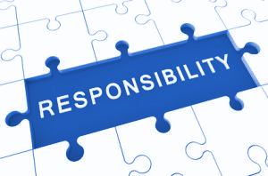 | I am honest and truthful, and take responsibility for my actions.
- I do the right thing because it is the right thing to do  - I am honest and truthful to myself and others  - I take responsibility for my actions and their consequences | Beginning | Developing | Applying
 | I can talk about what doing the right thing looks like, and usually tell the truth. | I do the right thing and tell the truth most of the time. | I always do the right thing, and support others to do the same.
 | I am learning that I am responsible for my actions and their consequences. | I understand that I am responsible for my actions and their consequences. | I reflect on my actions, and their consequences to myself and others, before  I do things.

Community / Hapori
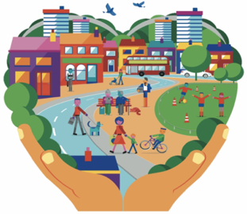 | I contribute towards our school and community, and build positive relationships with others.
- I work together with others to contribute to our school and support our community  - I recognise and accept individual differences  - I build positive relationships with others  - I care for others and look out for them | Beginning | Developing | Applying
 | I can talk about what contributing to our school and the community looks like, and share basic ideas about what I could do. | I contribute positively to our school and the community, without being prompted, most of the time. | I independently look for new ways to contribute to our school and the community.
 | I can talk about how we are all different and unique, and share basic ideas on what being a good friend looks like. | I show respect and acceptance towards others, and am friendly and caring towards others most of the time. | I am respectful and caring towards others, celebrate our individual differences, and support others to do the same.

Courage / Māia
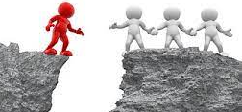 | I am brave in challenging situations, and  do not give up when things are hard.
- I am brave when faced with new situations  - I show resilience and determination when things are hard  - I help others to be brave. | Beginning | Developing | Applying
 | I can talk about what being brave looks like, and  when I might need  to be brave. | I take action in challenging situations, even though I am feeling afraid or uncertain. | I embrace challenges and demonstrate a willingness to step outside of my  comfort zone.
 | I am learning to be brave when faced with new situations. | I persevere when things are hard, and do not  give up. | I act as a role model, inspiring and helping others to be courageous.

Our Fox Glacier School Inquiry Model

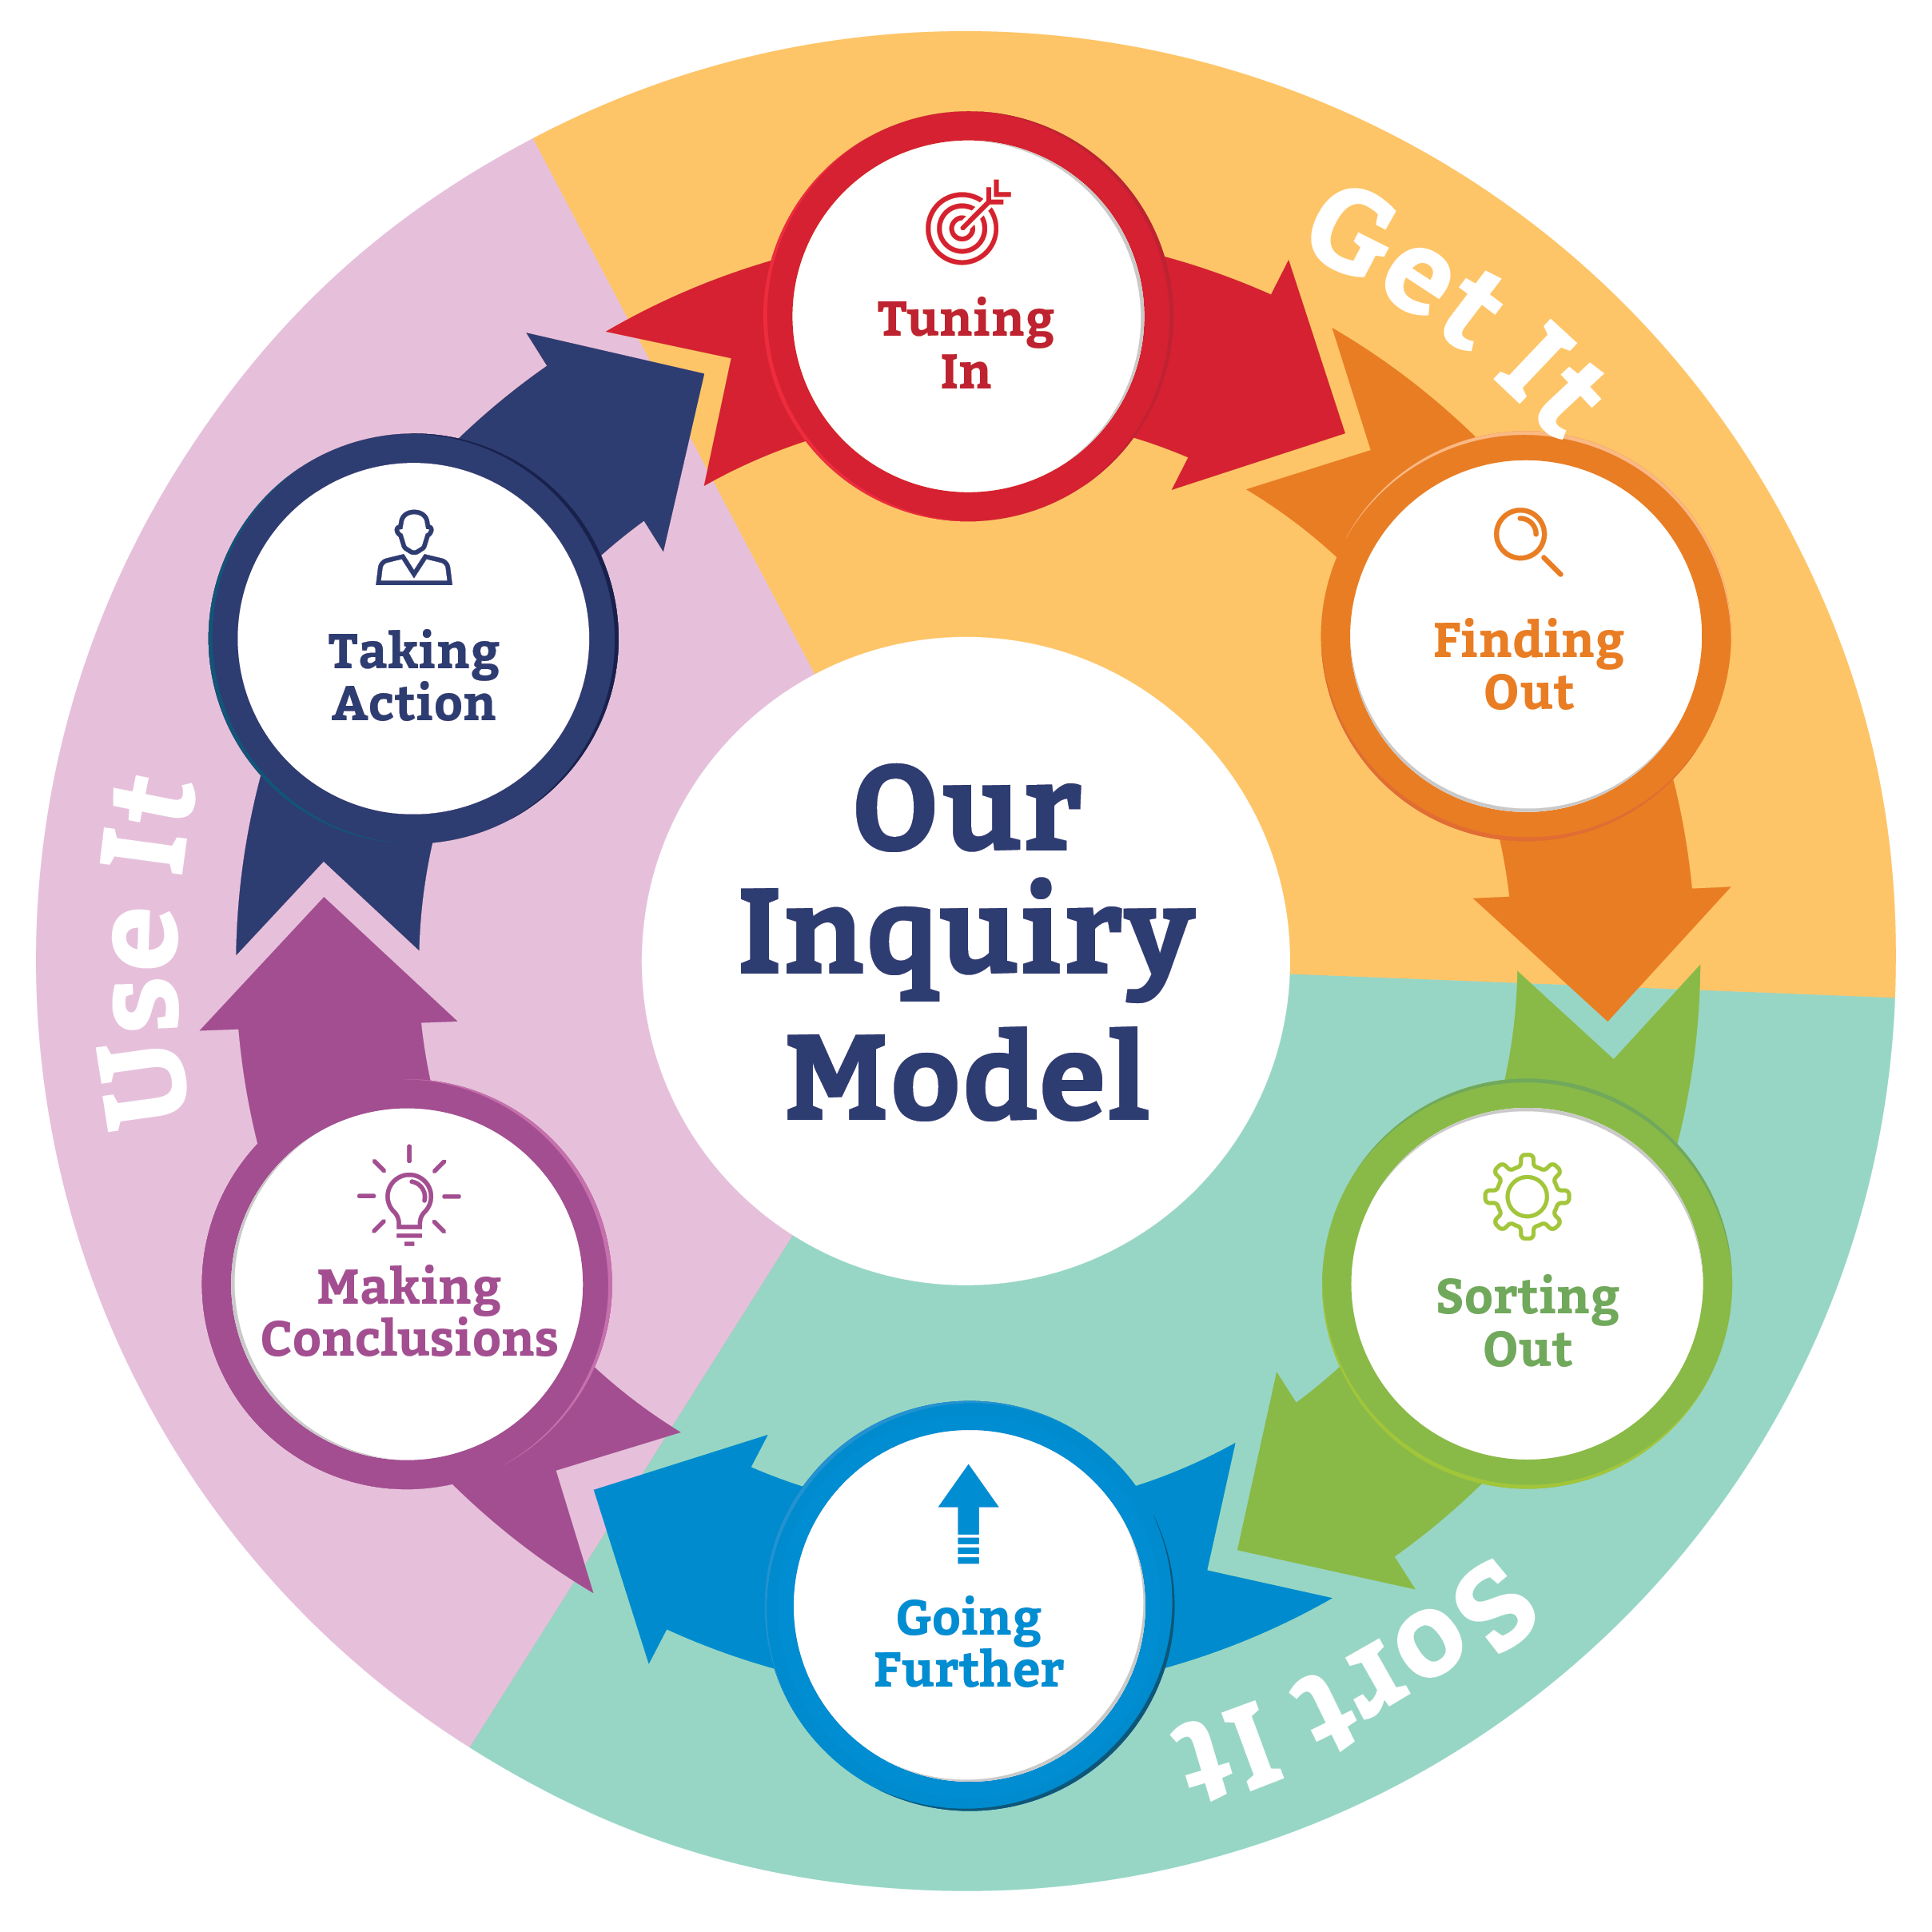

Our learning design model GET IT - SORT IT - USE IT defines the cycle of learning within a lesson, a unit, or a theme. The verbs below classify some of the actions that are appropriate at each stage.

Tuning In  Finding Out  Think about different ways to build my knowledge | Sorting Out  Going Further  Deepen my  understanding | Making Conclusions Taking Action  Reflect on, share and apply my new knowledge

- Find out what I already know about this topic and what I still want to know.  - Form a question and use resources to help me find information. | - Organise my information and check I have answered my question.  - Go further by adding more detail to my answers and asking more questions if I need to. | - Think about what I know now and make conclusions about it by sharing what it means to me and others.  - Take action by using my new knowledge to help me in my next learning situation, or to make something better for myself or others.

Brainstorm  Practise  Find  Define  Experiment  Predict | Sort  Order / Sequence  Assemble  Analyse  Compare / Contrast  Infer  Summarise  Consider  Synthesise  Negotiate  Connect | Solve  Decide  Teach  Innovate  Generalise  Justify  Design  Create

Implementation of the Curriculum

Responsive Curriculum Overview

- Teachers plan units of learning that are informed by the analysis of students’ needs, passions, opportunities and individual teacher strengths.
- Students are encouraged and supported to take ownership of their learning by setting their own goals, and devising a plan to achieve them (where am I at? where do I want to go? how will I get there?).
- Units of work include rich collaborative learning opportunities, allow for student agency, and utilise both local expertise and our local environment wherever practicable and appropriate.
- Teachers use the Backward By Design planning process to identify desired results, assessment tasks, and learning events.
- Science, Social Sciences, the Arts, and Technology, feature at least once each year as a main focus in inquiry units planned for the classroom.
- Students have opportunities to learn languages and/or other curriculum areas with specialist teachers through the Virtual Learning Network programme.
- English and Mathematics is taught separately, and links into units of work wherever possible.
- Te Reo Māori is incorporated into the daily life and learning of the school, and taught specifically for at least 2 terms per year. Units of inquiry include aspects of te Ao Maori and bicultural perspectives. Student expertise is utilised and is an important part of our programme.
- Health and Physical Education is taught at least twice a week each term.

The New Zealand Curriculum Learning Areas

In English, students study, use, and enjoy language and literature communicated orally, visually, or in writing.
In the arts, students explore, refine, and communicate ideas as they connect thinking, imagination, senses, and feelings to create works and respond to the works of others.
In health and physical education, students learn about their own well-being, and that of others and society, in health-related and movement contexts.
In learning languages, students learn to communicate in an additional language, develop their capacity to learn further languages, and explore different world views in relation to their own.
In mathematics and statistics, students explore relationships in quantities, space, and data and learn to express these relationships in ways that help them to make sense of the world around them.
In science, students explore how both the natural physical world and science itself work so that they can participate as critical, informed, and responsible citizens in a society in which science plays a significant role.
In the social sciences, students explore how societies work and how they themselves can participate and take action as critical, informed, and responsible citizens.
In technology, students learn to be innovative developers of products and systems and discerning consumers who will make a difference in the world.

An Overview of the Planning Process

Understanding By Design is the planning framework used in order to plan learning programmes. It is a fully integrated 3-step planning framework that enables professionals to teach for understanding.
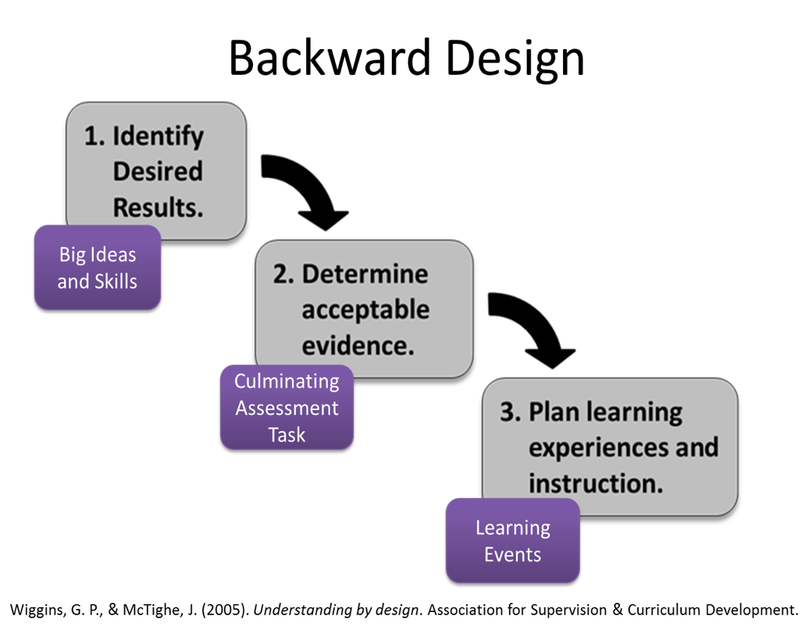

Links to Key Supporting Documents

Inclusive Procedures

Literacy Progressions (reading and writing)

Mathematics and Statistics Progressions

Maori Progressions

Student Agency

Fox Glacier School Implementation of the New Zealand Curriculum

